1.Find all the information about each product:

db.products.find({})



2.Find the product price which is between 400 to 800:

db.product.find({ product_price: { $gte: 400, $lte: 800 } })

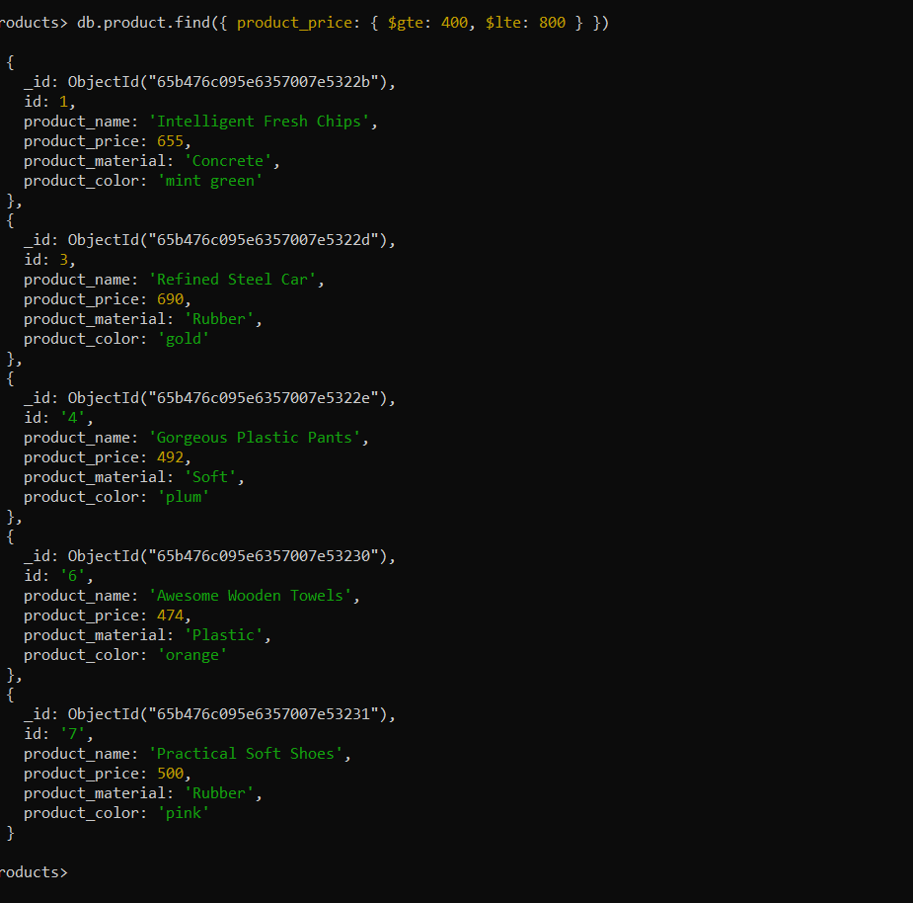

3.Find the product price which is not between 400 to 600:

db.product.find({ product_price: { $not: { $gte: 400, $lte: 600 } } })

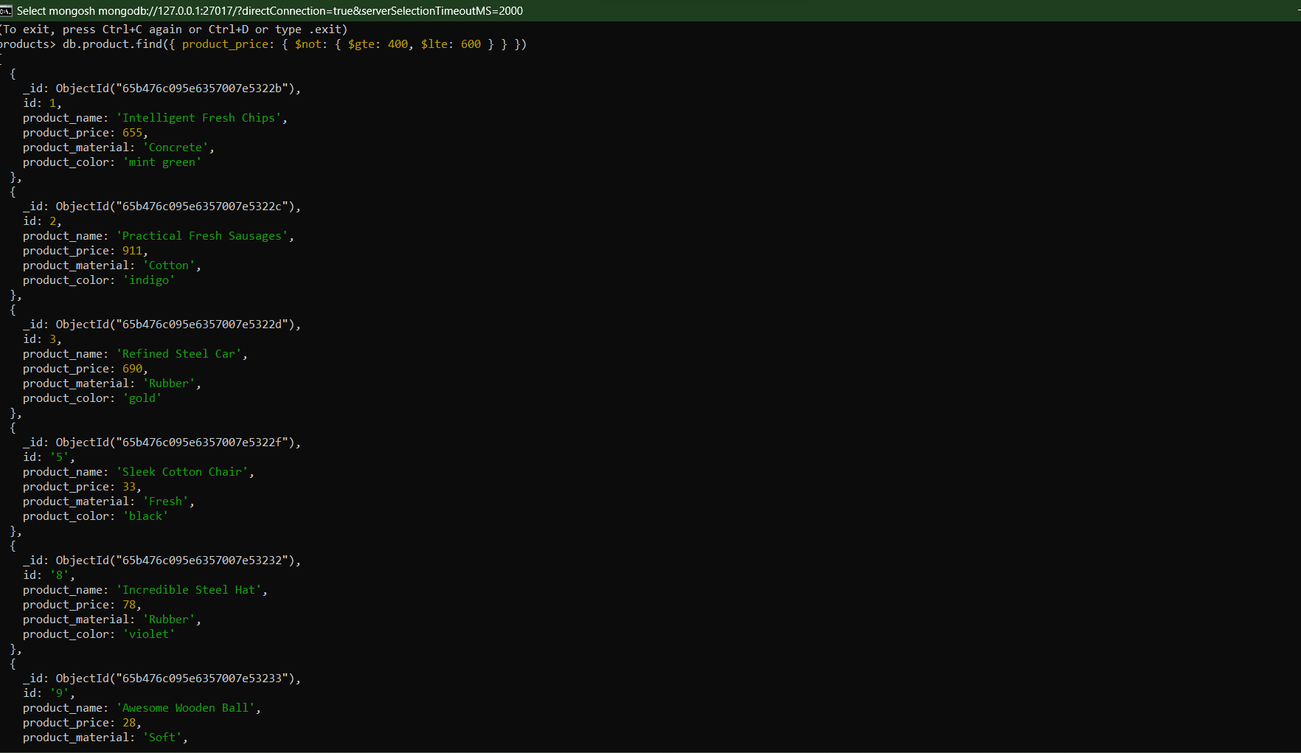

4.List the four products which are greater than 500 in price:

db.product.find({ product_price: { $gt: 500 } }).limit(4)

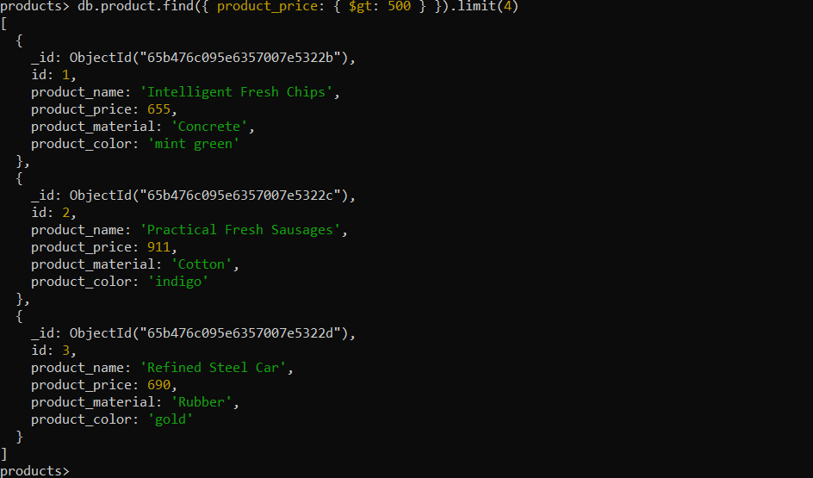

5.Find the product name and product material of each product:

db.product.find({}, { _id: 0, product_name: 1, product_material: 1 })

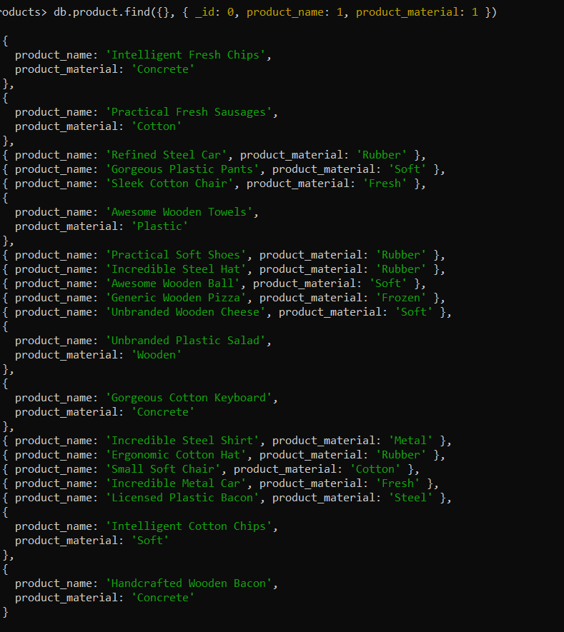

6.Find the product with a row id of 10:

db.product.findOne({ _id: 10 })

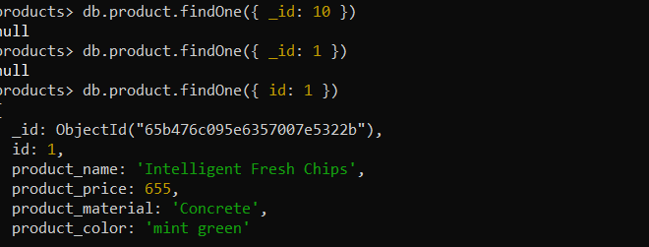

7.Find only the product name and product material:

db.product.find({}, { _id: 0, product_name: 1, product_material: 1 })

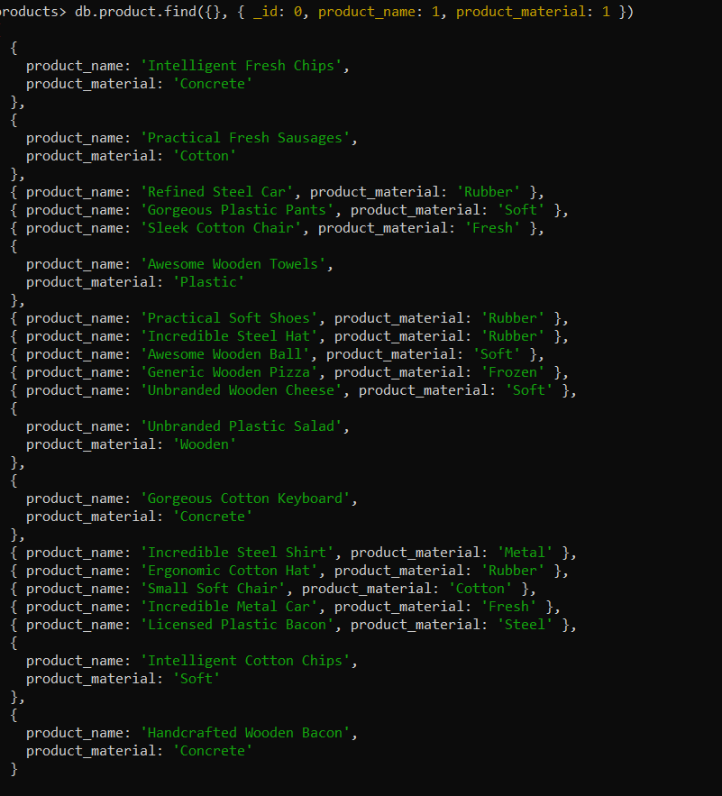

8.Find all products which contain the value 'soft' in product material:

db.product.find({ product_material: /soft/i })

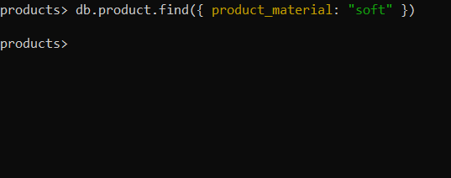

9.Find products which contain product color 'indigo' and product price 492.00:

db.product.find({ product_color: 'indigo'},{ product_price: 492.00 })

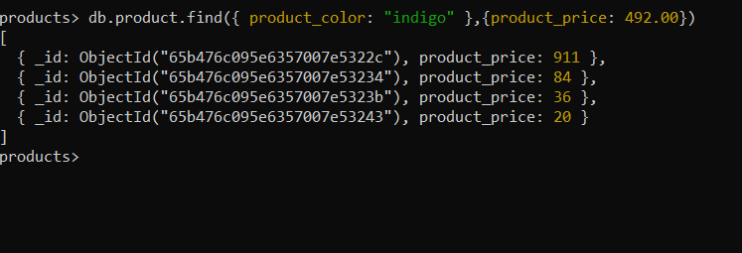

10.Delete the products which have the same product price value:

db.product.deleteMany({ product_price: { $eq: <20> } })

